click to unsubscribe

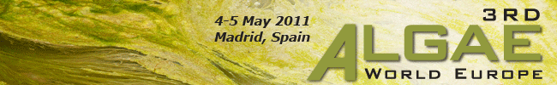

Send to a Friend | Save Dates

CMT’s highly-acclaimed Algae World series returns to Europe for the third time this 4-5 May 2011, in Madrid, Spain. While the agenda is being finalized, we’ve put together a special offer for you!

As a hint of what you can expect at the 3rd Algae World Europe, we’re offering you an exclusive white paper download – right now at no cost!

In collaboration with leading algae media Oilgae, we're excited to present you with a brand-new white paper entitled “Algae Status Report: How Far Are We from Commercialization?”.

Drawn from Oilgae’s expertise as they provide you first-hand insights and in-depth knowledge into today’s algae industry. This is a Must-Claim download that provides not only valuable information on:
- Major players and their algae cultivation strategies
- Updates on progress & efforts of prominent algae projects worldwide
- Forecast of trends and analysis of the industry’s development in the next ten years
- Examples and updates on large oil companies joint ventures and tie-ups – signifying their belief in the potential of algae
- And much more…

BUT ALSO facts you should about the Key Barriers to Algae Fuels grouped under 3 main categories:
Key Challenges, Algae Fuel Production Cost, and Entry Barriers.

So if you want to access a real world status report on today’s algae industry that shed light on little-known areas of algae production – now is your chance! Simply click here for download now!

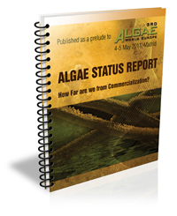

P.S. Remember to Reserve your Seat for the 3rd Algae World Europe – Click here to Pre-Register now! Contact me at leelin@cmtsp.com.sg with your questions.

Yours Sincerely,  LeeLin Tan (Ms), Marketing Division  CMT - Centre for Management Technology  Tel: +65 63469146 | Fax: +65 6345 5928  Email: leelin@cmtsp.com.sg  www.cmtevents.com  www.futureenergyevents.com/algae | Organised by  

